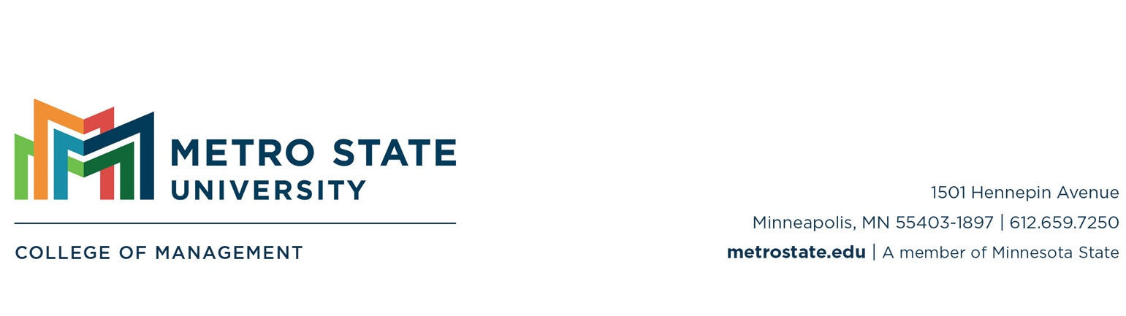
Faculty Professional Development Report

Faculty: Senanu Okuboyejo Department: MIS
Period: May 2023 - April 2024 (AY23-24)

This report highlights all endeavors and activities to support and enhance my professional growth and development at the college and university during the period under review. This report also serves as a roadmap to ensure the satisfactory fulfillment of my position's requirements per Article 22 Section B of the IFO Contract.

- I have demonstrated the ability to teach and perform effectively in other current assignments.
- Establish and maintain a teaching portfolio – I taught the following courses in Fall 2023 and Spring 2024 -
    - MIS 380 – Business Intelligence and Analytics - Asynchronous
    - MIS671 – Problem Formulation and Data Presentation – Hyflex and Online Synchronous

- Teaching: Demonstrate an interest and growth in education. I aim to foster, improve, and sustain learner-to-learner and learner-to-instructor communication and collaboration.
- Foster learner-to-learner and learner-to-instructor communication and collaboration
  - Timely grading and releasing students' papers and assignments with constructive feedback. I adhered to established timelines and deadlines and was flexible with students who required some form of accommodation. Students were promptly provided with constructive feedback and opportunities for the feedback to be implemented and re-submitted. The students found the feedback valuable and effective, improving their disposition and perception of the course. (See attachment for some students' responses to the feedback)
  - Increase student participation in class through cooperative learning activities, active student-student interactions, and analyzing materials, strategies, and methods. Students worked on collaborative semester projects and participated in group discussions.
  - Utilize student-teacher interactions and strategies that encourage independence, self-efficacy, and self-reliance.
    - Weekly announcements/snapshots of the requirements for the week.

- Review existing class materials based on students' assessment and feedback. I revised existing course materials and topics to reflect current practices especially in analytics.
- I integrated teaching and learning high-impact practices (HIPs) into my courses to enhance individual and collective student experience.
  - Collaborative semester projects: working with others prompts students to solve problems while actively considering the input of peers with unique perspectives. (interaction, collaboration, and experience with diversity). The project also promotes a sense of shared purpose and achievement.
  - Service Learning/ Community-based learning: I introduced practitioners' sharing sessions in my classes to bridge the gap between industry and academia and build career competencies. These sessions expose students to the practical aspects and, to a certain extent, the knowledge and expertise needed to translate theories and concepts into practice.
    - Practioners' Sharing Session 1: Understanding the Data Journey – Arun Seghal, 10/30/2023 (Fall 2023)
  - The HIPs provided and enhanced the following learning experiences for the students:
    - Periodic, structured opportunities to reflect and integrate learning – Students had opportunities to engage in reflective practices. The semester project required students to reflect on what they learned and synthesize disparate pieces of information. These contemplative practices challenged and encouraged students to synthesize their learning and reframe their perspectives. Students were also tasked with providing feedback on group presentations. Clear instructions on the feedback process facilitated the learning associated with this practice and prompts to help with constructive feedback.
    - Opportunities to discover the relevance of learning through real-world applications – link theory with practice beyond the classroom
    - Public demonstration of competence - Beyond the feedback and evaluation they receive from their audience, preparing their work for others prompts students to synthesize and articulate their learning with attention to accuracy and quality.

- Develop and acquire skills necessary to teach my courses effectively.
  - I signed up for Metro State's Educator Learning Communities (ELC) for the fall semester. My team explored "Engagement in Asynchronous Classrooms." The ELC activities and strategies provided support that strengthened innovative teaching for Metro's student population. These strategies focus on engaging students and encouraging them to participate in their learning actively.
  - Participant at the CFD (Center for Faculty Development) "Embracing the Flipped Classroom Workshop" – 09/13/2023
  - I attended the "Digication ePortfolio" showcase, organized by the Center for Educational Innovation. The showcase demonstrated how portfolios can be used in various subject areas and for learning goals. I look forward to transferring this high-impact practice to my courses.
  - Kahoot! EDU Fall Meetup (20th September 2023): Learn time-saving and productivity-boosting tips for my classes
  - The Good and The Bad: Why Generative AI has changed grading Forever by Colin Conrad, on 12/05/2023. This session is part of the "Leading in Learning: A Pearson Lunch, Learn and Meet Webinar Series." These webinars provide actionable insights to help educators navigate the current education landscape.
  - 'Howtoon with Powtoon' LIVE Q&A with Powtoon's Team, on 01/17/2024 - Howtoon with Powtoon is a monthly guided session where you can receive expert advice on the latest best practices in video creation using Powtoon.
  - I attended the 16th Annual Conference on Higher Education Pedagogy, February 7-9, 2024, at The Inn at Virginia Tech & Skelton Conference Center, Blacksburg, Virginia.
  - Participant in several CFD (Center for Faculty Development) Workshops for professional development (See Criteria 2 for more details)
  - Participant in several NED (Network for Education Development) Webinars and Short courses: These help build awareness, develop knowledge, skills, and abilities, and provide space for reflecting and revising. (See Criteria 2 for more details)
  - Cengage 2024 Empowered Educator Virtual Conference: Exploring GenAI in Higher Education (02/14/2024 – 02/15/2024) (Certificate attached)

- Equity and Inclusion Activities:
- I designed and incorporated an assignment in my course, MIS 671, introducing diversity and inclusion learning outcomes.
- Collaborative semester projects: During the academic year, I introduced an engaging element to the curriculum by incorporating collaborative semester projects on data analysis within my course at the graduate level. This initiative aimed to empower students with practical skills in descriptive and diagnostic analysis while emphasizing the critical importance of addressing Diversity, Equity, and Inclusion (DEI) issues, specifically focusing on closing equity gaps.
- I made my classes more financially accessible.
- Incorporating Open Educational Resources (OER) and leveraging social media learning methods have been integral to my courses.
- Additionally, I obtained educational licenses for the software utilized in the class, which was provided to students for one year. These licenses offer access to the necessary tools and include learning paths, facilitating the acquisition of essential knowledge and skills for the workplace, thus promoting career readiness.
- Student Feedback: Student feedback was primarily positive, from a positive learning experience. The communication channels were effective, with timely instructor responses and tools like MS Teams facilitating group work. The course materials varied in quality, with some students needing more resources and advanced practical exercises. The engagement with peers was generally positive, with collaborative projects and group discussions enhancing the learning experience. Suggestions for improvement included more explicit guidelines and expectations for assignments, introducing in-person classes, and enhanced interactive elements to increase engagement. The emerging themes from the course evaluation are summarized by the word cloud in Figure 1 below. The suggestions for improvement will be incorporated into the PDP for the next academic year.
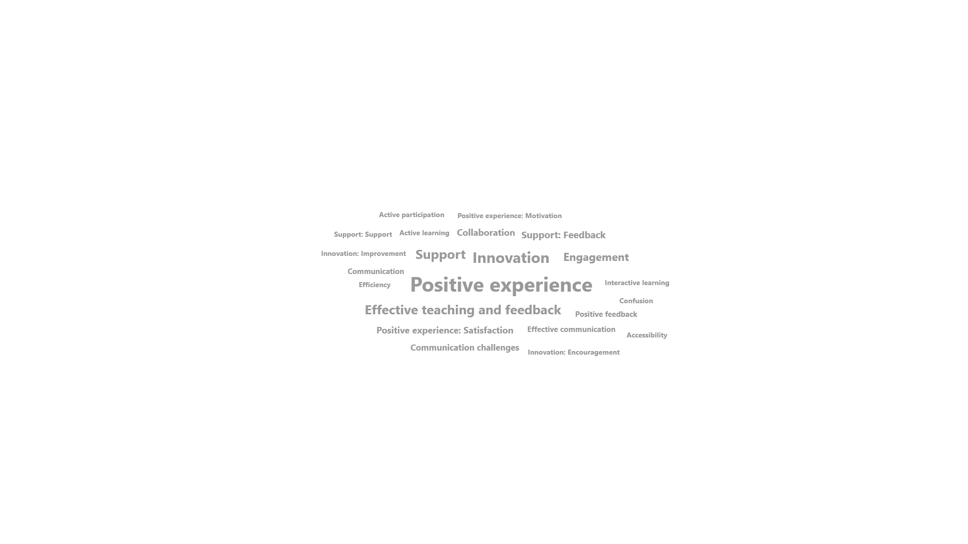
Figure 1: Emerging themes from Course Evaluation and Assessment

- Scholarly/ Creative/Professional Achievement/Research:
- I received a professional development grant (PDG) to attend the 16th Annual Conference on Higher Education Pedagogy.
- Active participation in faculty development, capacity-building initiatives, or other significant scholarly endeavors as appropriate for my discipline and role.
  - Guest Faculty Presenter – Department of Nursing, N703-01: Research and Advanced Evidenced Based Practice, Fall 2023. I presented on Data Analysis Best Practices.
  - Complete Tableau Learning paths to enhance my data analysis skill set relevant to MIS380 and MIS671. The skills from these courses helped me review the syllabi, providing industry-relevant skills while achieving the course and program objectives.
    - I completed the Tableau Consumer learning path. This learning path comprises skills to read and interpret data to make better, more informed business decisions. It provides the core competencies, such as navigating Tableau's interface and foundational data literacy concepts, so you can effectively work with the dashboards and reports others create. It included concepts such as data types, variables and field types, distributions, and variations.
Badge – Interact with Dashboards and Reports, available https://www.credly.com/badges/1fb2b49d-e531-495a-9cb3-6caeab4db81e/public_url

    - Design Informative and Visually Appealing Dashboards by Tableau, https://www.credly.com/badges/35df6ada-f04a-4f65-8725-9a8b12be68bf/public_url
    - Dashboard Design: Visual Best Practices (certificate attached)

  - Participate in the SAP University Alliances Virtual Trainings for university faculty to earn trainer skills
- 1st June: Grand Gestures: Storytelling with AI (Artificial Intelligence) and Snap. https://www.credly.com/badges/e243c873-96df-4fb6-9d2c-8ed401cbab85/public_url
- 20th June: SAP Build Apps - https://www.credly.com/earner/earned/badge/c6a4e380-b9c5-44df-89e0-155fda1a27eb
- 21st June: Business Process Modeling with SAP Signavio - Incorporate into teaching the MIS671 module on Business Processes as an alternative to Visio. Badge is available at https://www.credly.com/badges/2f52e3c9-3977-4465-b549-606f7552ccfe/public_url

- Participate in curriculum review and development.
  - Health Informatics (HI) graduate certificate: This program will explore the convergence of technology and healthcare, empowering students to bridge the gap between these two fields effectively. The graduate certificate will provide students with a multidimensional perspective on the application of technology within the healthcare sector. By delving into this intersection, students will gain valuable insights that enable them to integrate information technology into healthcare practices effectively. This holistic understanding will prepare them to address the unique challenges and opportunities presented by the evolving landscape of health information technology. To build capacity and develop competencies for the HI certificate, I participated in the following trainings:
    - The National Heart, Lung, and Blood Institute (NHLBI) of the National Institutes of Health (NIH) virtual workshop on Big Data Integration: Unlocking the Potential for Enhanced Epidemiological Research, September 27-28, 2023 (Virtual Participant). The virtual workshop addressed the challenges and opportunities associated with integrating different data sources and types and leveraging established data tools/techniques for population-based research.
- Collaboration in the scholarly growth of students, peers, and other scholars
  - Active Member, Persuasive Computing Lab, Dalhousie University, NS, Canada
  - Collaborating with faculty within and across departments for research projects (Peer collaboration)
- Publish in one conference proceedings or journal outlet
  - Senanu Okuboyejo, Jawad Haqbeen and Takayuki Ito (2023). Evaluating the performance of Machine Learning Classifiers on Predicting Hypothyroidism for Public Healthcare Good, KICSS 2023 IIAI Letters on Informatics and Interdisciplinary Research. https://iaiai.org/letters/index.php/liir/article/view/166/134
  - Senanu Okuboyejo, Mousumi Munmun & Steven Walczak (2024). Exploring Controllable Dimensions of Depression App Usage Using a Topic Modelling Approach submitted to MWAIS 2024
  - Senanu Okuboyejo & Miriam A. Nkemnji-Enohnyaket (2024). Influential Determinants of Adult Wellbeing: Exploring the Impact of Lifestyle Choices on Body-Weight Variations within the Canadian Population (submitted to the Indian Journal of Science and Technology, revision ongoing)
  - Senanu Okuboyejo & Steven Walczak (2024). An Evaluation of Affective Processes of Users of Depression Management Apps, submitted to Academia Mental Health & Wellbeing (under review)

- Present at an academic conference.
  - Senanu Okuboyejo, Jawad Haqbeen and Takayuki Ito (2023). Evaluating the performance of Machine Learning Classifiers on Predicting Hypothyroidism for Public Healthcare Good, The 18th International Conference on Knowledge, Information and Creativity Support Systems (KICSS2023) September 20-22, 2023, Kitakyushu International Conference Center, Kitakyushu, Japan.

- Evidence of continuing preparation and study
- Active participant – Tuesday morning writing group
- I served as a reviewer for a journal/conference submission during the academic year.
  - Reviewer - Workshop on Democracy and AI (DemocrAI2023), November 16th, 2023, Jakarta, Indonesia
  - Reviewer - 15th ICT for Africa (ICT4Africa) Conference, Cameroon, July 2024

- I attended a research-related/academic conference or workshop. Participating in these conferences and professional activities is an opportunity to advance my visibility and insight as a scholar.
  - 2023 Americas Conference on Information Systems (AMCIS), Panama City, Panama, 10th – 12th August 2023 (Virtual participant)
  - NIH virtual workshop on Big Data Integration: Unlocking the Potential for Enhanced Epidemiological Research, September 27-28, 2023.
  - AI in Health Conference 2023, October 9 - 12, 2023, BioScience Research Collaborative (BRC), Rice University, 6500 Main St, Houston, TX 77030
- I attended a teaching, assessment, and/or student development conference or workshop. These conferences shape my teaching, learning, and evaluation competencies towards building student competencies, institutional capacities, and job sustainability.
  - I signed up for Metro State's Educator Learning Communities (ELC) for the fall semester To nourish the scholarship of teaching and its application to our unique students and their learning. This ELC also focused on equitable assessment practices.
  - CFD (Center for Faculty Development) Workshops
    - Embracing the Flipped Classroom Workshop – 09/13/2023
    - Teaching with Chat GPT: A Workshop on Interactive AI in the Classroom – 10/19/2023
    - Inclusive and Accessible Courses Workshop – 11/15/2023
  - NED (Network for Education Development) webinars and short courses: These help build awareness, develop knowledge, skills, and abilities, and provide space for reflecting and revising.
    - Step-by-step Guide to Create Authentic Assessments (Academic technologies) – 10/30/2023
    - Technology Tips for Universal Design for Learning (Academic Equity) – 10/31/2021
    - Humanizing Student Assessments with Video or Audio Feedback (Academic Technologies) – 11/02/2023
    - The Basics of Accessible Documents (Accessibility) – (01/11/2024)
    - Finding Accessible OERs (01/15/2024) – Accessibility
    - Getting Started with the Scholarship of Teaching and Learning (02/01/2024) - SoTL
    - Manage Course Dates to Improve Student Engagement (01/22/2024) – Academic Technologies (Short Course)
    - Teaching with AI: Community of Practice
  - 16th Annual Conference on Higher Education Pedagogy, February 7-9, 2024, The Inn at Virginia Tech & Skelton Conference Center, Blacksburg, Virginia.
  - Cengage 2024 Empowered Educator Virtual Conference: Exploring GenAI in Higher Education (02/14/2024 – 02/15/2024)
    - AI & Academia: A New Era in Curriculum Design – Lewis Heuermann
    - Creative AI Storytelling for Teaching & Connecting – Joseph Dobbs
    - Writing Possibilities in the Age of Generative AI – Laura Vernon, Laurie Cubbison, Kim Gainer
    - In the Blink of an AI: Assessment Open AI Revolution - Corinne Hoisington
    - Beyond Lectures: AI-Driven Applied Activities – Lisa Jacovsky
    - BloomAI: Creating AI Prompts for Research and Learning – Phillip Olla
    - Revolutionizing Learning with AI-Generated MCQs – Chulhee Jun
    - Students Reimagine Education in an Era of GenAI
    - Providing Student Feedback Using Large Language Models

- I participated in local or regional conferences or professional organization activities.
  - IFO (Inter Faculty Organization) Faculty of Color Mentoring Workshop Series:
    - Relationship between mentor and mentee - 05/12/2023. Participants were exposed to strategies to build and foster trusting mentor/mentee relationships. The workshop also explored the diverse types of communication within the academy and how faculty can leverage each type to build respectful and workable relationships necessary for effective and successful mentorship teams.
    - Preparing for Tenure & Promotion - 09/22/2023.
    - Legal Guidance for MinnState International Faculty – 11/03/2023
    - Faculty of Color Mentorship Summit, 01/19/2024. Theme: Building Mentoring Connections that Facilitate Growth. Keynote: Dr. Doug Hall - Vice President of Career and Professional Development, Highpoint University

  - IFO- Metro FA Faculty Issues Committee Annual Promotion and Tenure (P&T) Workshop on Friday, 10th November, 2023
  - Metro State University's Faculty of Color mentorship program (FoCMP):
    - The tenure and promotion process: questions and insights – 11/17/2023
    - Securing a grant: Learning from our university's successful grant writers – 02/23/2023
  - PC member at conferences and workshops
    - Workshop on Democracy and AI (DemocrAI2023), November 16th, 2023, Jakarta, Indonesia
    - 15th ICT for Africa (ICT4Africa) Conference, Cameroon, July, 2024
  - COM Lunch and Learn Series
    - Leadership in the Digital Age: The Importance of Interpersonal Connection – Kevin Jones, 09/26/2023
    - Psychological Types, work, and life – Tania Casado, 10/24/2023
    - Relevance, Belonging, and Growth Mindset in Economics: Differences across Institution Types – Allen Bellas, 11/07/2023
    - The Power of Empathic Communication, Speaking and Listening with Compassion - Dr. Wayne Valim, 01/23/2024
    - Work/Life Integration: Knowing Your Values and Making Intentional Changes to Engage with Impact – Janet Tilstra, 02/06/2024
    - Peer Coaching Scholarship and Practice – Marcia Hagen & Erica Berte, 02/20/2024
- Engage in life-long learning for continuous capacity building and development.
  - Attended the GoTo Webinar: GoToWebinar - Transforming academic research with the AWS (Amazon Web Services) Cloud, 05/17/2023
  - I completed the following Tableau courses with certificates
    - Tableau Consumer learning path.
    - Dashboard Design: Visual Best Practices
    - Getting Started with Tableau Prep Builder
  - I also completed the following LinkedIn Learning Courses
    - Learning SAP Analytics Cloud
    - How to Research and Write Using Generative AI Tools

- Contribution to student growth and development.
- Student Advising
  - I participated in the new faculty advising training and the monthly advising forum to prepare me for student advising roles.
- Student Support Services: I have been actively engaging with students to provide support outside of regular office hours. This includes conducting one-on-one meetings with students, particularly those experiencing challenges with their assignments, especially those with low grades or who struggle to grasp the assignment requirements. These sessions address individual needs, offering clarifications, guidance, and additional explanations to ensure each student's comprehension and success in their academic endeavors. By fostering a supportive and personalized approach, I aim to empower students to overcome obstacles and thrive in their coursework.
- I provided letters of recommendation and support to students.
- I incorporated seminars/conference presentations into my courses to equip students with career-readiness competencies such as public speaking and oral communication.
  - Student Scholars Conference: Students in the MIS 671 class present their collaborative projects at the Student Scholars Conference on 04/16/2024.
- Guest Lecturer – Nursing Research Class, Department of Nursing. I presented Data Analysis/ Statistical Analysis.
- I signed up for Metro State's Educator Learning Communities (ELC) for the fall semester. My team explored "Engagement in Asynchronous Classrooms."
  - Participating in the ELC "Engagement in Asynchronous Classrooms" provided an opportunity to explore and enhance strategies for fostering active participation and learning in online environments with flexible schedules. The community explored various tools, techniques, and best practices to create interactive and collaborative asynchronous learning experiences. I gained insights into promoting student engagement, effective communication, and building a sense of community in virtual classrooms where real-time interaction is impossible. The sessions also taught me practical skills to optimize the asynchronous learning environment for enhanced student involvement and successful online education outcomes. These skills are an addition to strengthening innovative teaching for the student population at Metro State.
- I incorporated learning paths in my courses. This initiative is a proactive step towards preparing the students for success in the modern business landscape. It equips them with the skills and confidence to analyze data, make informed decisions, and excel in their careers. Tableau has an active user community and forum. Students were encouraged to engage with these communities, which can help them connect with professionals, learn from others' experiences, and stay updated on industry trends.
  - Tableau Consumer learning path: This learning path provides the core competencies, such as navigating Tableau's interface and foundational data literacy concepts, so students can work with dashboards and reports effectively, especially when created by other individuals. It included concepts such as data types, variables and field types, distributions and variations, correlation, and regression.

- Service: Provide service to the department/college/university or support a significant initiative
- Serve on a departmental/college/university committee
  - Served on the departmental search committee
  - CBM DBA and MBA Steering Committee
  - CBM Graduate Committee
  - CBM/IFO Outstanding Student Award (OSA) Committee
  - CBM/IFO Academic Affairs Committee
  - Served as a co-deep reader for the CBM-IFO FA association
  - Student Scholars Committee (University)
- Participate in and support Diversity, Equity, and Inclusion (DEI) Activities.
  - Member, Black Equity – ERG for people of African descent
  - Participated in the Office of Equity and Inclusion activities to support diversity, equity, inclusion, and anti-racism.
    - Office of DEI – Convocation Session: Combatting Microaggressions in the workplace
    - Office of DEI – Convocation Session: Accessibility Updates & Answer Session for Faculty
    - Office of DEI - Convocation Session: Office of Equity & Inclusion Info Session
  - I became an Equity champion to promote and close the gaps in equitable hiring. I served as an equity champion on the MIS search committee.
  - I participated in the CFD's Innocent Classroom, a transformative workshop series for Metro Faculty that explores an approach to anti-racist instruction. The workshop has equipped me with the following skillset -
    - Provided a new anti-racist framework and skillset to identify, assess, and eliminate barriers to student success
    - Learn the fundamentals of a faculty-driven, student-centered practice of replacing stereotype threat and implicit bias with trust.
    - Explore individual and organizational strategies to end the negative impact of racial bias and racial and ethnic stereotypes.

- Member, Teaching with AI: Community of Practice (Minnstate NED Initiative)
- Participant in the "Conversations with Colleagues" bi-monthly webinar series organized by NED. This is one of the activities that provides an opportunity to engage in rich conversation in small and large groups and network with colleagues across the Minnstate system. Conversations with Colleagues aims to foster a support network for faculty and staff across Minnesota State.
- I signed up for Metro State's Educator Learning Communities (ELC) for the fall semester. My team explored "Engagement in Asynchronous Classrooms."
  - To strengthen relationships among educators at Metro State, thereby reducing isolation.

